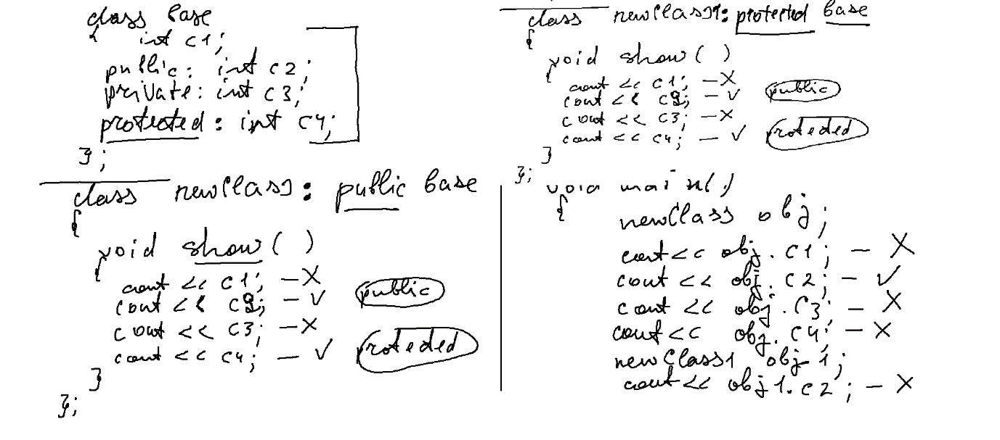

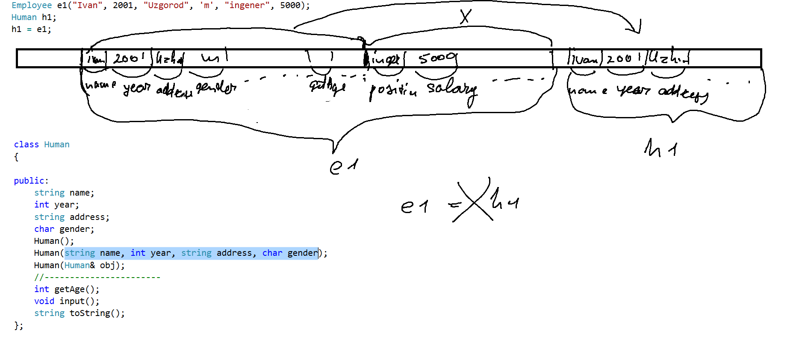

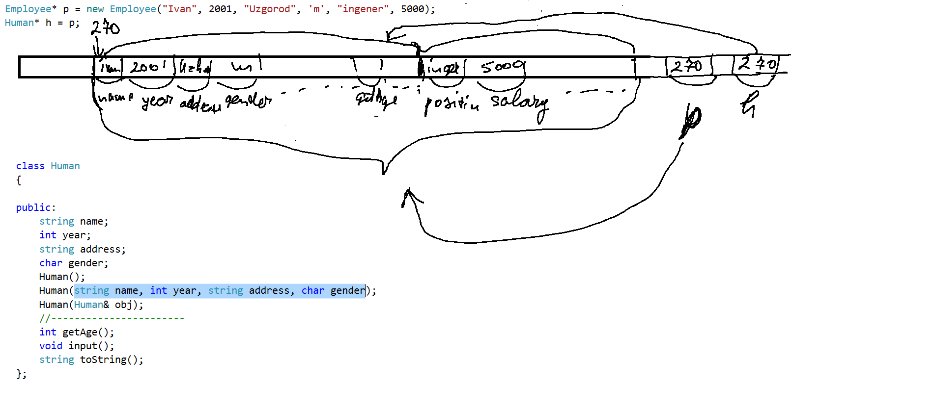

--------------------------- Human.h --------------------

#pragma once

#include<string>

#include<iostream>

using namespace std;

class Human

{

public:

string name;

int year;

string address;

char gender;

Human();

Human(string name, int year, string address, char gender);

Human(Human& obj);

//-----------------------

int getAge();

void input();

string toString();

};

-------------------------------- Human.cpp ----------------

#include "stdafx.h"

#include "Human.h"

#include<string>

#include<iostream>

using namespace std;

Human::Human() :Human("no name",1900, "",'u')

{

}

Human::Human(string name, int year, string address, char gender)

{

this->name = name;

this->year=year;

this->address = address;

this->gender=gender;

}

Human::Human(Human & obj):Human(obj.name,obj.year,obj.address,obj.gender)

{

}

int Human::getAge()

{

return 2017-year;

}

void Human::input()

{

cout << "name:";

cin >> name;

cout << "year:";

cin >> year;

cout << "address:";

cin >> address;

cout << "gender:";

cin >> gender;

}

string Human::toString()

{

return name+", "+to_string(year)+ ", " + address+ ", " + gender;

}

---------------------------- Employee.h ------------------

#pragma once

#include "Human.h"

class Employee : public Human // Employee є нащадком класу Human

{

public:

string position; //Додали нові поля

double salary;

Human* director;

//Конструктори нащадка

Employee();

Employee(string name, int year, string address, char gender, string position, double salary);

Employee(Employee& obj);

double getSalaryPerYear(); //Новий метод

void input(); //Перевизначення

string toString(); //Перевизначення

};

-------------------------- Employee.cpp ------------------------

#include "stdafx.h"

#include "Employee.h"

Employee::Employee():Human()

{

salary = 0;

position = "";

}

Employee::Employee(string name, int year, string address, char gender, string position, double salary):Human(name,year,address,gender)

{

this->position = position;

this->salary = salary;

}

Employee::Employee(Employee & obj):Human(obj)

{

position = obj.position;

salary = obj.salary;

}

double Employee::getSalaryPerYear()

{

return 12*salary;

}

void Employee::input()

{

Human::input();

cout << "position:";

cin >> position;

cout << "salary:";

cin >> salary;

}

string Employee::toString()

{

return Human::toString()+"," +position+", "+to_string(salary);

}

--------------------------------- main --------------------------

// ConsoleApplication112.cpp : Defines the entry point for the console application.

//

#include "stdafx.h"

#include "Human.h"

#include "Employee.h"

#include<iostream>

using namespace std;

int main()

{

Employee* p = new Employee("Ivan", 2001, "Uzgorod", 'm', "ingener", 5000);

Human* h = p;

h->year = 2005;

Employee e1("Ivan", 2001, "Uzgorod", 'm', "ingener", 5000);

Human h1;

h1 = e1;

Human* h3 = new Human(h1);

Human h2(h1);

return 0;

}